**Coursework 1- Game Website**

**Name: Dristi Bhugun**

**Student ID: M00846514**

**Module: CST 2120 Web Application**

**Date of submission: 13/12/23**

**Tutor: Mrinal Sharma**

**TABLE OF CONTENTS**

Introduction 4

How to play? 4

The Pages 5

Homepage (index.html) 5

About us (about.html) 5

Contact us (contact.html) 5

Copyright (copyright.html) 6

Hot to play (how-to-play.html) 6

Login Page (Login.html) 6

Input Validation 8

Error Handling 9

Ranking Functionality 9

Languages and Tools Used 10

Difficulties Encountered 10

Conclusion 11

**TABLE OF FIGURES**

1 Homepage 5

2 About Us 5

3 Contact Us 6

4 How to Play 6

5 Login form 7

6 Signup form 7

7 Gaming Window 7

8 Leaderboard 8

# Introduction

First of all, the website I am designing is called “Brick Breaker”. My web-based Brick Breaker game, built with HTML, CSS, and JavaScript, offers a simple yet addictive challenge. Break the bricks using a bouncing ball, test your reflexes, and have some fun. It consists of Login, Sign Up page where player can create their account. In game window user can navigate to Play, Help and view Leaderboards where highest scores will be displayed. It also has navigation bar to check other pages like About us, how to play and Home button. In footer section, DMCA, Contact Us links are provided.

# How to play?

**Signup for game**

* Go to signup page
* Enter username, email and password to create an account
* Username and password must be at least 4 characters long
* Click on Signup button.
* Your account will be created

**Login**

* Go to login page
* Enter your username and password for login the website.
* Click on login button

**Play**

* Click on play button to start game
* Save ball from falling by moving paddle with mouse
* You will get 100 points per brick

**Leaderboard**

* Check your rank in leaderboard
* Logged in username will be highlighted with red color
* Ranks are sorted with highest to lowest score

# The Pages

## Homepage (index.html)

* It contains Header with logo and navigation buttons.
* Play button will redirect to login.html page

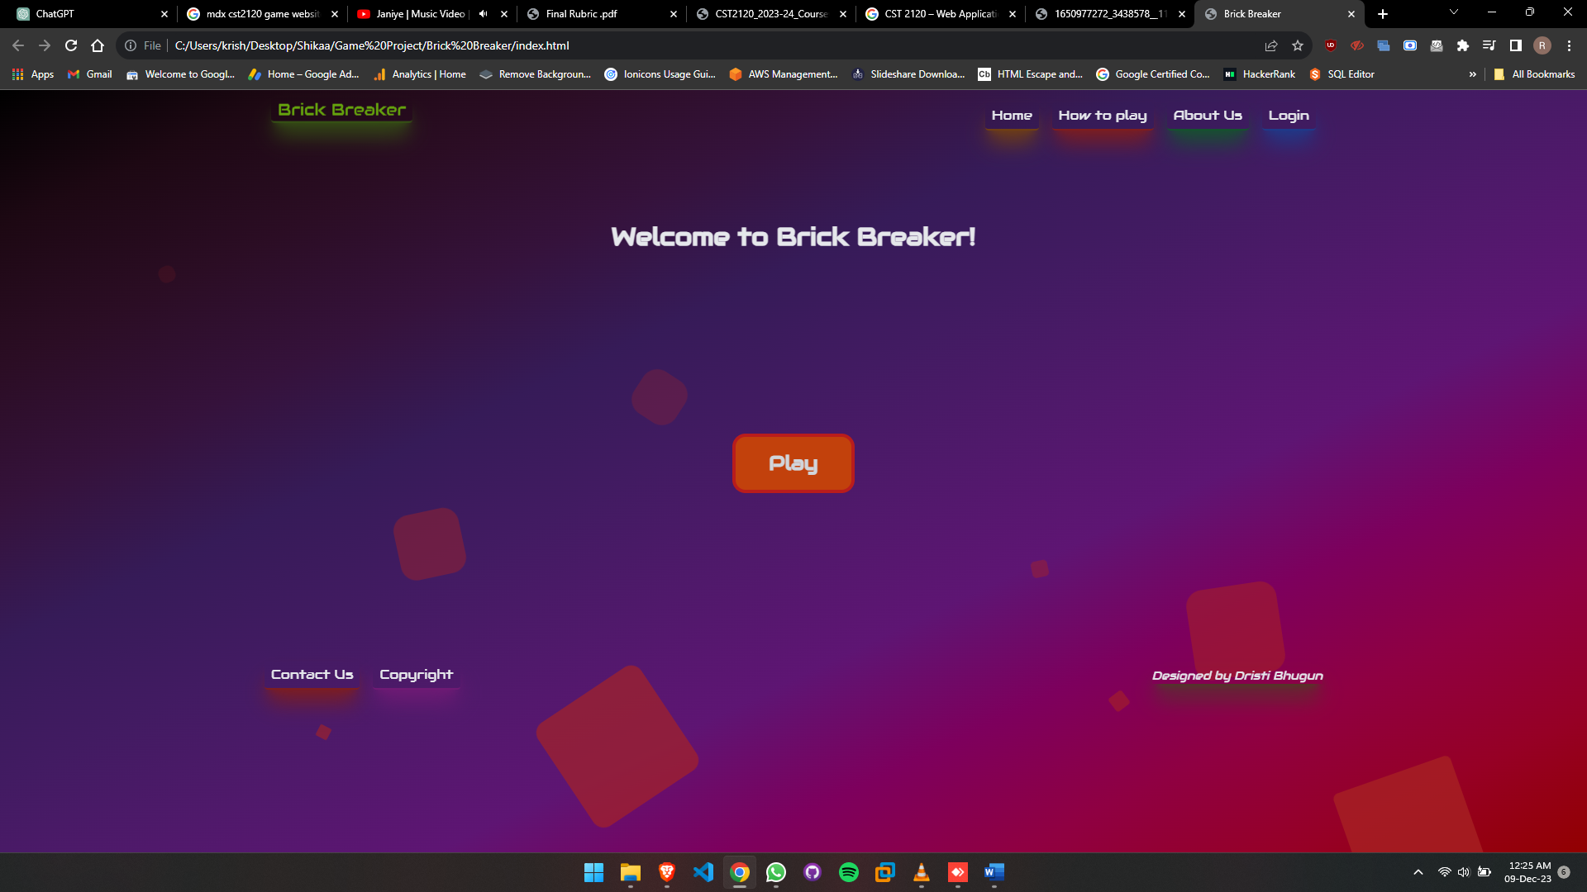

1 Homepage

## About us (about.html)

* Contains email if user want to interact with us.

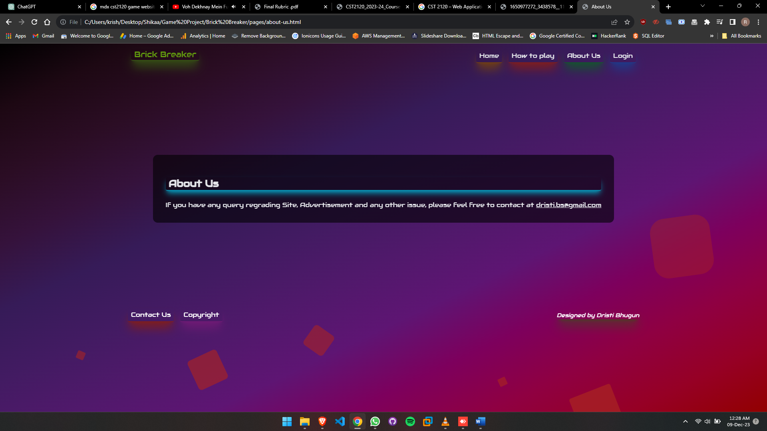

2 About Us

## Contact us (contact.html)

* Contains a form to get response of users

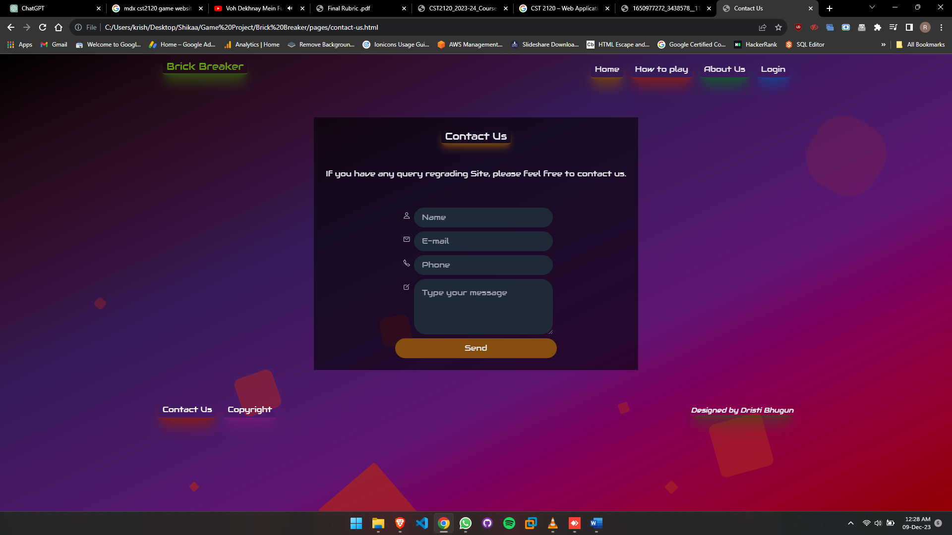

3 Contact Us

## Copyright (copyright.html)

* Display copyright belongs to developer

## Hot to play (how-to-play.html)

* Display all rules to play game and how to SignIn

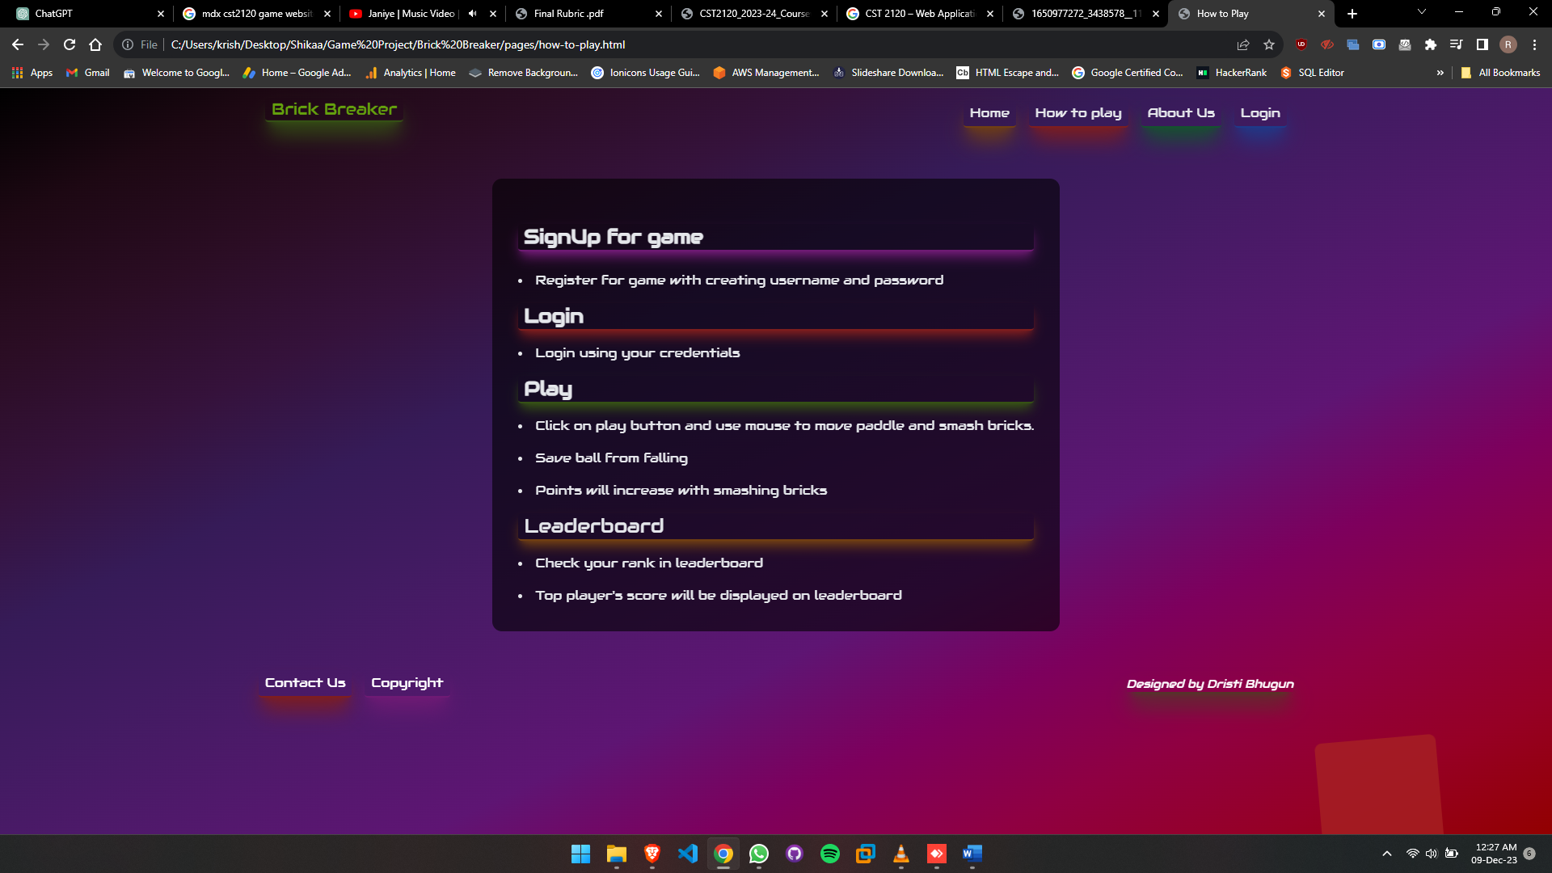

4 How to Play

## Login Page (Login.html)

* Displays Login and Signup page

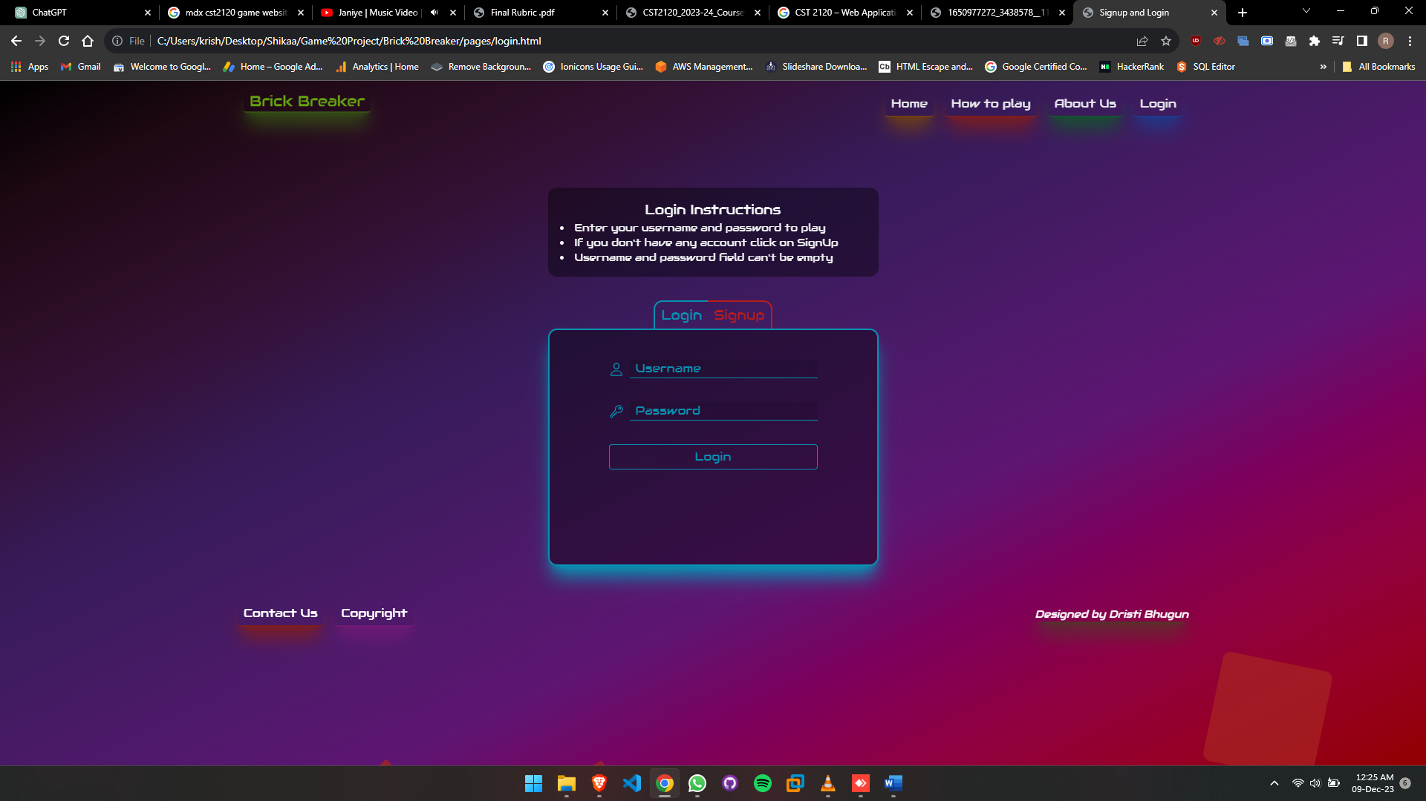

5 Login form

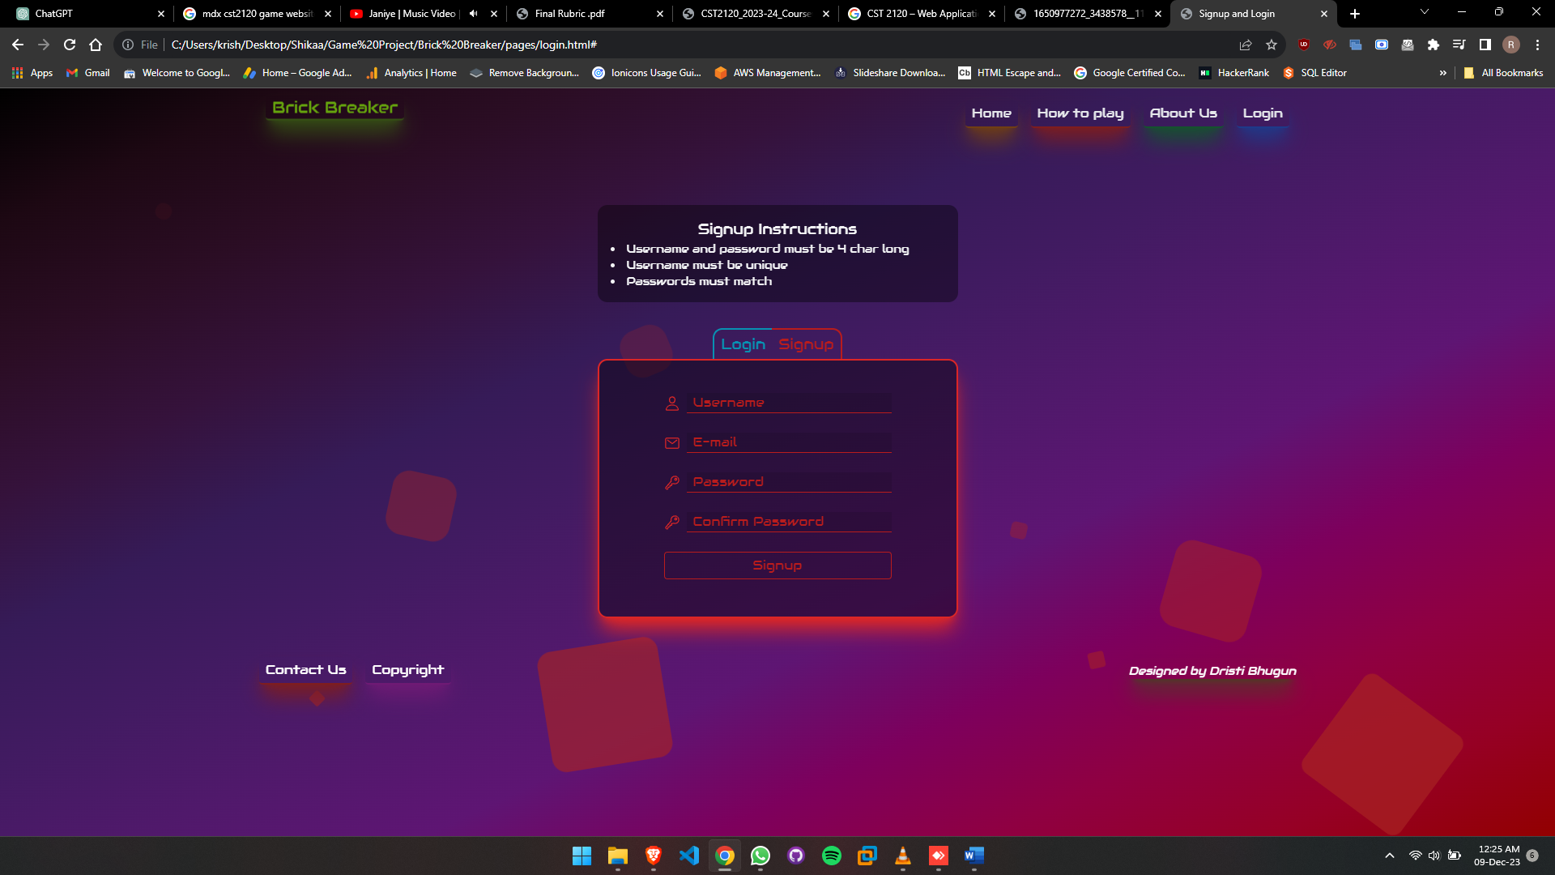

6 Signup form

* After login, User can play game

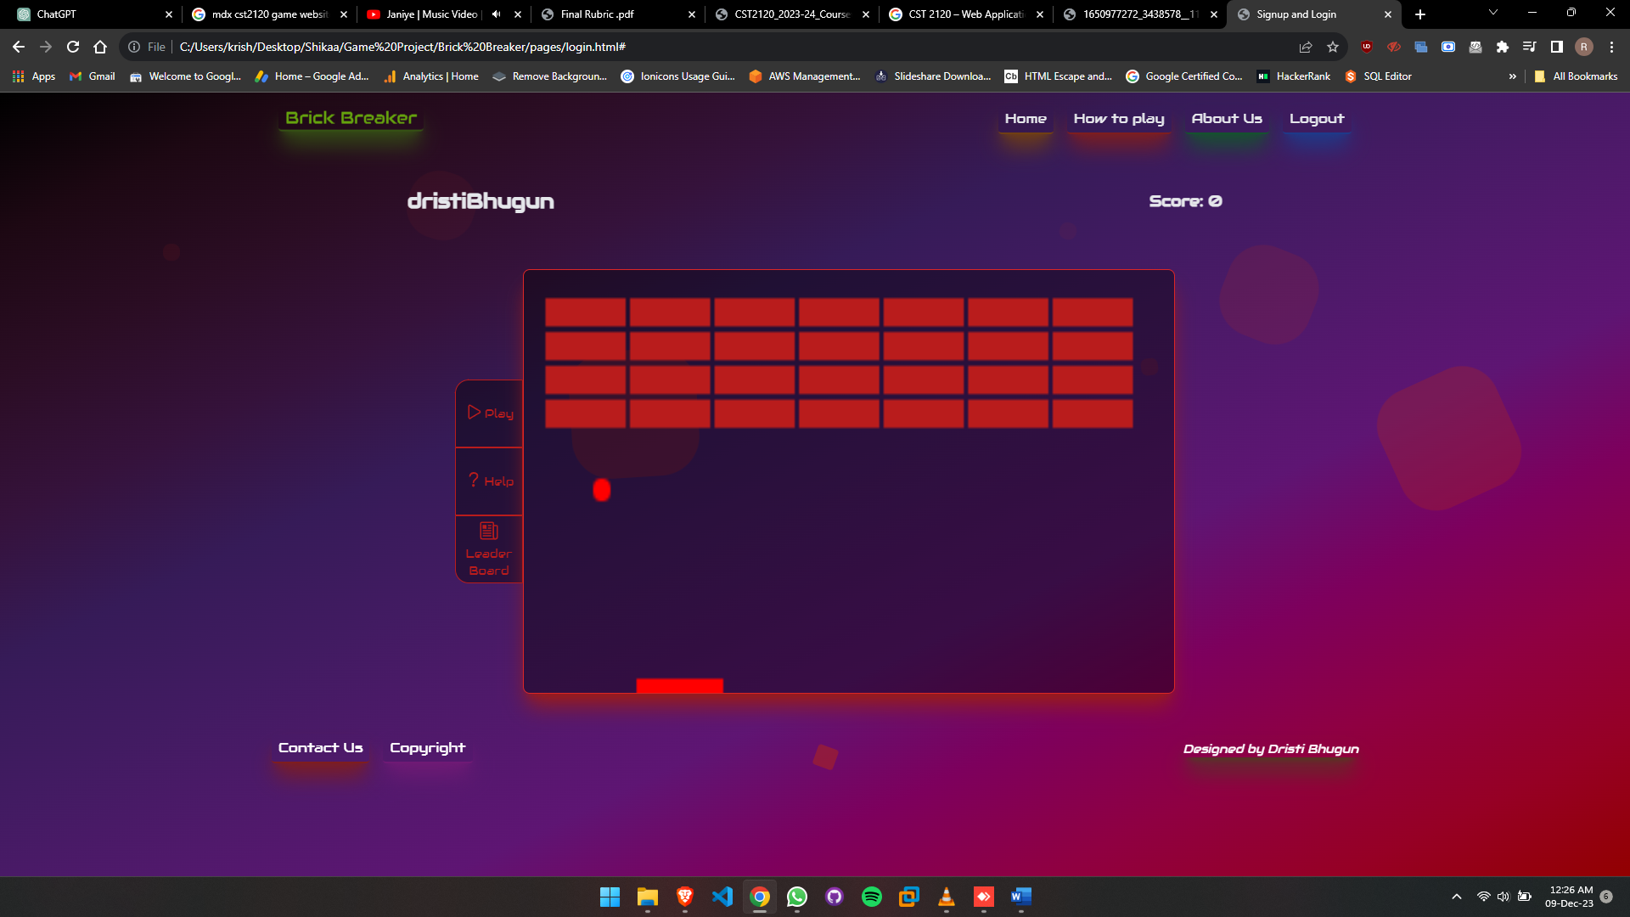

7 Gaming Window

* User can see leaderboard in same page.

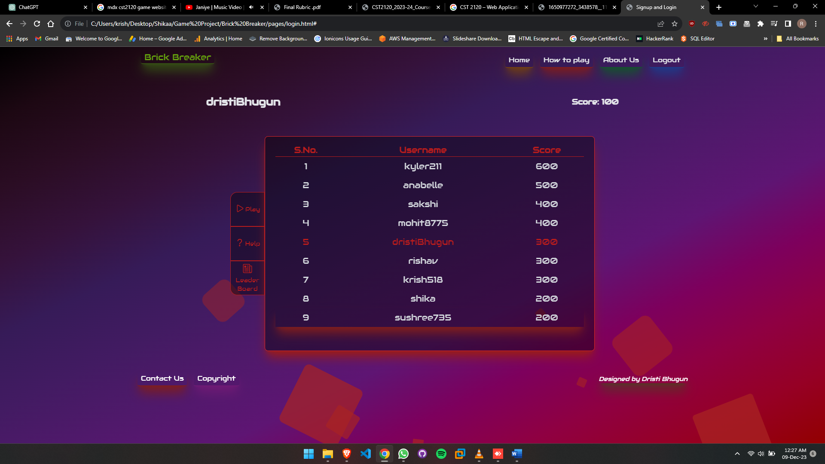

8 Leaderboard

# Input Validation

**Null Username and Password:**

Ensures both username and password are provided to prevent incomplete submissions, enhancing form data integrity.

**Duplicate Username Check:**

Verifies the uniqueness of usernames to prevent registration with existing usernames, maintaining a distinct user database.

**Password Matching Check:**

Confirms that the entered password and its confirmation match, ensuring accuracy and avoiding input errors during user registration.

**Username Length Validation:**

Requires a minimum of four characters for usernames, promoting security and preventing overly short or insecure identifiers.

**Password Length Validation:**

Mandates a minimum password length of 4 characters, enhancing security measures.

# Error Handling

**Null Username and Password:**

**Error Handling:** Displays a message prompting the user to fill in both username and password fields for successful submission.

**Duplicate Username Check:**

**Error Handling:** Notifies the user that the chosen username already exists, prompting them to select a unique identifier.

**Password Matching Check:**

**Error Handling:** Alerts the user if the entered password and confirmation do not match, instructing them to re-enter matching passwords.

**Username Length Validation:**

**Error Handling:** Informs the user that the username must be at least four characters long, preventing submission until the requirement is met.

**Password Length Validation:**

**Error Handling:** Prompts the user to create a password with a minimum length of 4 characters, guiding them to enhance security.

# Ranking Functionality

When user open Leaderboard, it will load Json with some pre-defined username and scores from game.js and it will add user’s latest username and score in local storage and Json will be sorted according to scores.

# Languages and Tools Used

**HTML5:**

Markup language for structuring web content, providing a foundation for creating interactive and responsive websites.

**Tailwind CSS:**

Utility-first CSS framework enabling rapid and efficient styling, fostering a modern and customizable design approach.

**JavaScript:**

Dynamic scripting language for web development, empowering interactive and engaging user experiences on the client side.

**JSON (JavaScript Object Notation):**

Lightweight data interchange format, easy for humans to read and write, and simple for machines to parse and generate.

**Google Fonts:**

Diverse collection of web fonts offering high-quality typographic choices to enhance the visual appeal and readability of websites.

**VS Code:**

Feature-rich source code editor by Microsoft, known for its extensibility, speed, and support for various programming languages and extensions.

# Difficulties Encountered

• Creating responsive layout for game frame which will adjust

navigation while used in Tab or Mobile screen resolution.

• Highlighting current username and score in leaderboard

screen.

• Merging Game window, Help and Leaderboard in one page.

# Conclusion

In conclusion, the Brick Breaker game website, crafted with HTML5, Tailwind CSS, JavaScript, and JSON, showcases a dynamic and visually engaging gaming experience. The fusion of HTML5's structural prowess, Tailwind CSS's streamlined styling, and JavaScript's interactivity ensures a seamless user interface. Leveraging JSON for data handling and Google Fonts for typography, the website achieves both functionality and aesthetic appeal, offering an immersive platform for users to enjoy the thrilling Brick Breaker game.